Streamlining the Data Access “Layer” of NCIA

Problem
Within the NCIA code base, especially “ncia-services-commons”, there is not a seemingly clear set of principles for data access. Even though the software happens to work for the most part, there are a number of objects that appear to do similar things and are called by different (but similar) names. Without clear principles, changing existing code or adding new code becomes more difficult. For example, a developer might not be able to find an existing piece of code that does what is required and in turn replicates the code.
In some ways, it is just a “name game” or a “shell game”, but with important consequences for maintenance:
- Properly layered or decomposed software will likely lead to more reusability.
- It becomes possible to make a blanket statement like: ‘all DAO will throw exceptions instead of sitting on them’ without worrying about trying to think about whether it applies to all variations like QueryHandler, ResultSetManager, xxManager, etc.

Solution
The solution is to streamline the objects that do similar things if possible, or else clearly enunciate the roles and responsibilities for each different type of object in the system.
Ideally, this layer will be reduced to a collection of “Data Access Objects” that exchange Transfer Objects with the business logic of the application. This pattern basically exists within NCIA already, but there is other code that behaves similarly with different names and perhaps slightly different behavior. Business logic and data access should not be intertwined and should only communicate by way of a DTO.
Any “cleanup” of the “managed beans” in the presentation layer should likely be deferred until the data access and business logic are cleaned up as the managed beans will be dependent upon it.

Query, QueryHandler
The DICOMQuery and the DICOMQueryHandler together are of principal importance to the application. The former captures all the user-specified criteria on the search page. The latter generates HQL based upon the former.
The name of this pair of objects is somewhat misleading. For “DICOM query”, a better name would indicate that it returns patients or is a query whereby the criteria are user-specified.
There is an infrastructure for “queries”, “criteria”, “query handlers” and “criteria handlers”. There are factories and proxies to obtain these object one way or another (instead of direct invocation of a constructor). There are a few reasons for “objectifying” query/criteria:
- Being able to send the query somewhere.
For example, across the network in as part of a “remote query” or even to communicate across layers, say from the presentation layer to the business logic layer.
- Being able to save the query somewhere (on persistent storage)
The original requirements for building up this infrastructure aren’t clear at this point in time. At this point in time, the DICOMQuery is the only query that needs to be sent or saved anywhere. The other queries are generally simple “find” operations that would commonly be found in a DAO object and don’t appear to need to be objectified. “Less is more”, so:
- The query object should go away save the one
- The query handlers should be converted to DAO objects with find/read operations that will match the criteria from the query objects.
Less is more because adding a method to a DAO is a lot simpler than making a query, query handler, adding constants, etc.

ResultSet v. DTO
This leads to the fact that “query handlers” return what is called a “result set” in the existing code. In the Core J2EE pattern catalog, a “result set” is what comes back from a data source. That’s sort of what these objects are, but not exactly. The Hibernate objects that are returned from the HQL should probably be considered the actual result set as far as the pattern is concerned. If the system relied upon JDBC, the java.sql.ResultSet object would be the “result set”. Since what the “query handler” returns is used by business logic directly to make decisions, the return value really functions more like a DTO. Therefore result set objects should be named as DTO.
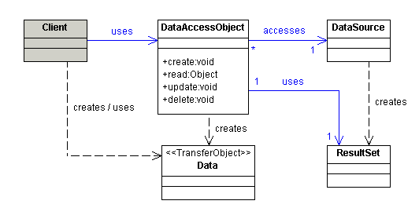

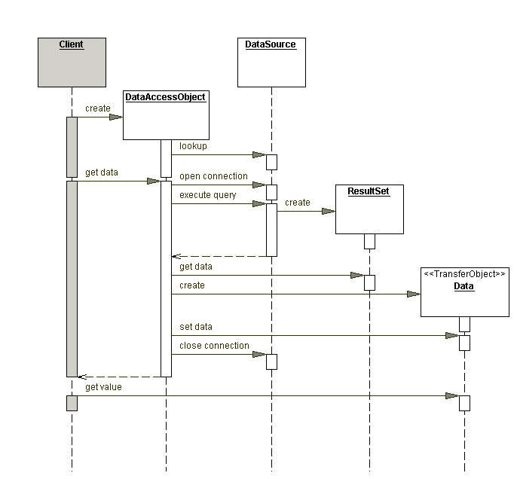

ResultSetManager
There are a few objects that fall in this category. These objects seem to function as a mix of DAO and business logic. The DAO part should be pushed down into a DAO and the business logic part can go into a new object without this confusing suffix.
- ResultSetManager
- VerifySubmissionResultSetManager –
- DataBasketResultSetManager –
- LatestCurationDateResultSetManager

Lookup Manager
This object is meant to be called by the presentation layer. It captures collections for display in the presentation layer. It can be considered a special kind of DAO that talks to the data source or else it can call other DAO. [Analysis in progress of mix between business logic and data access]
- StudyNumberMap
- QALookupManager
- ImageRegisterMap
- LookupManager

So-called Util Objects
The suffix “util” in a class name usually mean that over time, arbitrary junk will collect in that class that is hopefully at least tangentially related to the original intention of that object! All the data touching that goes on in “util” methods should be moved to an appropriate DAO object.
An object/method can be called “util” when it does fairly simple repetitive things that don’t necessarily belong in any one place, or belong in multiple diverse places.

Deployment Issues
The entire data access layer could possibly be encapsulated in a new and separate deployment unit. With the business logic in another deployment unit, this will help enforce the order of dependency (data access layer deployment unit won’t require the business logic deployment unit in order to compile and run).
The implementation for the DAO and the interface for the DAO could also be separate. This way the business logic module could depend upon the interface module, and never have access to the implementation module. For example, it could never mess with the Hibernate objects.

Exception Handling
All DAO should log their exceptions and throw them up for a higher power to deal with. A DAO shall never “sit” on an exception.

Logging
It is okay to compute query times “by hand” if necessary, but it can be avoided given that YourKit can be used and performance print out code can clutter the code.
It is okay to rely upon Hibernate logging for SQL logging, but given it doesn’t show parameter values for prepared statements, it is ok to log these parameters “by hand”. (Investigate Spring JDBC).
Any other logging is fine, but try to avoid too much clutter.

Leftover Thoughts
- Security is something that should be part of a business layer, NOT a data access layer. The data access layer can provide mechanisms to find data based upon a security criterion, but the business logic should make the ultimate decision about what to retrieve.
- Objectifying queries may assist in auditing queries and keeping statistics. On the other hand, maybe the DAO methods can be instrumented (via AOP) to accomplish the same goal if that’s even really applicable?
- Avoid creating “mother of god” queries…
- The system returns synthetic/primary keys as part of the result sets, etc. that come back from the database. I have mixed feelings about this. The pkid will allow faster querying in certain situations, but then again, it doesn’t seem like something that should make its way up to the business logic layer.

Manager
[Analysis in progress of mix between business logic and data access]
- MailManager
- ReportingDataStorageManager
- AuthorizationManager
- NCIASecurityManager
- QueryStorageManager
- QAUpdateManager
- QAHistoryManager
- ImageManager
- MarkupManager
- CurationManager

